File = Swiss German Prel Plan 090128
International Forest Policy Excursion
Switzerland-Germany 2009
Preliminary Version 2009-01-28. (This document contains nine pages.)
The excursion to Switzerland and Germany is rapidly approaching.
Highly interesting preliminary plans and other suggestions have already arrived.
Please read the latest suggestions and comments in this document!

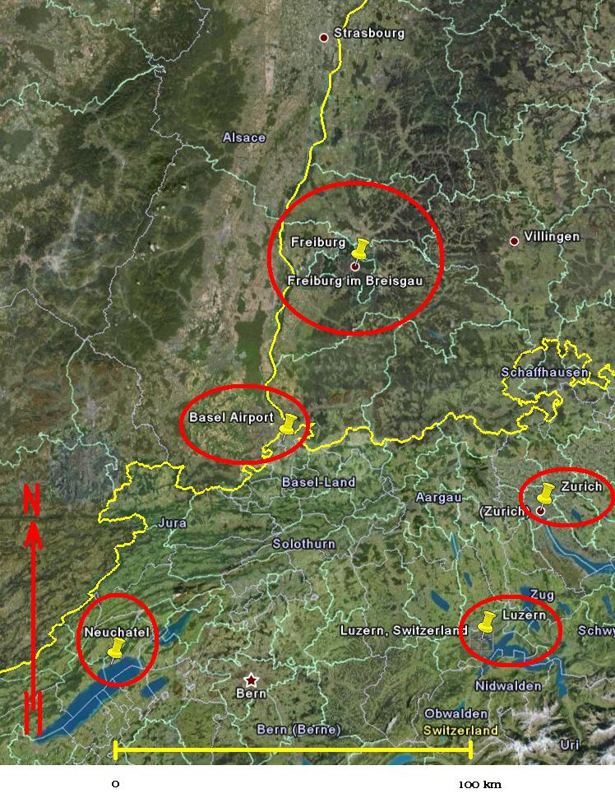

General facts and intentions:
Approximately 44 students and two professors from Sweden will follow the excursion.
The course is given as part of the Forestry Programme in Sweden.
The excursion is a part of the course: SH0026 International Forest Policy.
Objectives:
After the course, the student should know these things:
- Motives for forest policy.
- Swedish forest policy in perspective.
- International policy frameworks, overview of selected EU-policies.
- The historic and present use and importance of the forests in the countries visited during the course.
- The human impact on the land use and forests.
We try, in the forestry excursions to different countries, to include excursion points like these:
- Visits to typical forests with field trips and focus on country specific problems.
- Visits to forest industry mills such as saw mills and pulp mills and discussions of the most important connections to economic results, employment and other important conditions such as environmental effects.
- Presentations and discussions of forest policy and forestry laws such as forest acts at different levels.
- Discussions with representatives from forestry and forest industry firms and politicians with special focus on forest policy, labour policy and economics.
Special topics and themes that deserve special attention during the excursion of 2009:

Alternative methods of forest management, functions and suitability with respect to wider perspectives, in particular when we consider:

A. Global warming (CO2, storms etc.)
B. The international economic turbulence (financial crisis, market changes,
energi issues, employment, international trade).
Practical forestry excursion principles:
We rent a good bus with driver. This way the complete group moves between different locations during the excursion. A good microphone and speaker system makes it possible to discuss during the bus trips.
We rent suitable rooms in less expensive hotels (or similar) and try to order most meals such as breakfasts, lunches and dinners in advance.

*Message from Peter Lohmander 2009-01-28:

Dear reader,

Now, highly interesting and constructive suggestions have been obtained from our National Organizers in Switzerland and Germany!

In the text found below, a number of constructive suggestions have been included. The most recent suggestions have been sent from our National Organizer in Switzerland, Prof. em. Dr. Jean-Philippe Schütz, 2009-01-27 (1741 HRS). In the text, I wrote “JPS:” to indicate his suggestions. My own answers of 2009-01-28 are written with this green colour, starting with “PL:”. Also the constructive suggestions (earlier in the day) of 2009-01-27 from Prof. Dr. Marc Hanewinkel, “MH”, (and comments) are included in the text. The bus and other transport issues are connecting the excursions in both countries. Please, all of you, read the transport suggestions and comments concerning trains, busses and trams in Switzerland (with relevance and connections to transport in Germany).

My very best regards from Sweden,
Peter Lohmander 2009-01-28

Preliminary schedule
(More details will soon be available. Below, inputs from different sources have been combined. Please note that this is not the final schedule.)

April 21:
Flight from Umeå to Basel Airport
Bus to Couvet. Important: Please suggest a suitable bus company for the complete tour.
JPS: If you agree with these propositions (below), the bus could be organised from Basel airport (21 th april) to 23th april in the evening.
PL: Very good suggestion.Please proceed!
JPS: For the german excursion an other bus company could be found.
PL: Please, Marc and Lars, make the necessary arrangements.
JPS: I propose to make the reservation for Bevaix, Brienz and Zurich myself, as well as ordering the free pass for railway and collective rail ticket.
PL: Very good! Please proceed!
JPS: I could make a reservation ba a convenient bus company from Zuerich.
PL: Very good! Please proceed!
JPS: It is still to early for reservation the restaurants. This will happen later on.
PL: Very good!

Hostel in suitable place close to the excursion during Wednesday.
JPS: Sleeping 21/22 april in Bevaix (Motel de Bevaix) not far away from
Couvet. (I made a prereservation that I will confirm next week).
PL: Very good!

April 22: (Wednesday)
Day in Couvet- Canton Neuchâtel: Topic: Small scale close to nature silviculture.

General links:
http://www.prosilvaeurope.org/
http://www.prosilvaeurope.org/management.php

These links give maps, forest data and lots of information of relevance to forests in several countries, including the particular excursion in Couvet:
http://www.prosilvaeurope.org/network.php
http://www.prosilvaeurope.org/docs/doc178.pdf

Recent pictures from the forests that we will visit Couvet (and also from other forests): http://www.lohmander.com/Forest08/Forest08.htm

JPS: On 22th april after the visit of the small scale forest system in mosaic (Bevaix) we will travel to Brienz (Region Interlaken) and make a short stop in the city of Bern (Capital of Switzerland).
PL: Very good!

Hostel in suitable place close to the excursion during Thursday.
JPS: Hostel opportunity in the youth hostel Brienz.
I propose to make the reservation myself (may be they will ask if your
university have an international identification for youth hostels).
PL: Very good!

April 23: (Thursday)
Luzern: Topic: Timber Industry (laminated beams for high tech construction), Selling organisation in private owners. Harvesting in steep conditions. (It will be too early in the season to present a cable harvest.)

JPS: Excursion 23th april in Lungern (company on Website: nh-lungern.com, not the akustic part but the timber constructive one).

PL: Very good! Here is the link: http://www.neueholzbau.ch/wDeutsch/index.php
It would be very good if we can have discussions during this excursion point when the students can discuss some of the consequences of forest and industry policy issues with persons in the company.

JPS: In the afternoon visit of the new private owner organisation under auspices from the forest service,
PL: Very good! I hope that it will be possible to have discussions during this day when the students can discuss the central forest policy issues with persons in the forest owner association and if possible with some forest owners.
JPS: and may be visit a timber harvesting place.
PL: Very good!
JPS: On the way to Zurich short stop in the city Luzern.
PL: Very good!

The links below just represents a very mixed and preliminary selection. They give some general information that you may find interesting.
General links:
http://en.wikipedia.org/wiki/Lucerne
http://www.luzern.ch/
20. Internationale Forstmesse Luzern vom 20. bis 23. August 2009
http://www.fachmessen.ch/cms.asp?item=forst

Just for fun: Here, you find the YouTube perspective on the
forest sector in the region (selection by Peter Lohmander):
SAEGEWERK DAHINDEN in Hellbühl Luzern:
http://se.youtube.com/watch?v=DZHm9lbs8Bw
Passroad truth a Swiss Forest, between Aargau,Luzern
http://se.youtube.com/watch?v=bqdS3xT1RyQ
Forest Walk, Spreitenbach
http://se.youtube.com/watch?v=VynpP3TzqQg

Hostel in suitable place with respect to the activities during Friday.
JPS: Overnight in the Youth Hostel Zurich (in the city). I propose that you overnight three time there. PL: Very good!

JPS: During that time a bus is not necessary.
PL: Very good!
JPS: I propose to give the participant a three day free pass for public transportation within Zurich (essentially tramways).
PL: Very good!
JPS: The city of Zurich is well accessible with one of the best tramwaysystem in Europe.
PL: Very good!

April 24: (Friday)
Near Zürich (may be at the research station WSL, where there is more activity concerning global warming and economics) otherwise at ETH.

JPS: On 24th april I intend to organise the day at ETH (with different colleagues there).
PL: Very good! We hope that it will be possible to have discussions during this day (or earlier during the excursion) when the students also can meet stake holders in the forest sector and maybe some politician and, of course, relevant researchers at ETH, and discuss the central forest policy issues with them.

JPS: It is very simple to access by tramway.
PL: Very good!

Swiss Federal Institute for Forest, Snow and Landscape Research
http://www.wsl.ch/index_EN
http://www.wsl.ch/forschung/forschungsprojekte/schutzwalddynamik/index_DE?redir=1&
http://www.wsl.ch/forschung/forschungsprojekte/ccwatervalais/index_EN?redir=1&

ETH Zürich
http://www.ethz.ch/index_EN
http://www.pepe.ethz.ch/index_EN
http://www.lue.ethz.ch/GISTeam/forschung
http://www.lue.ethz.ch/GISTeam/forschung/dissjuerg.pdf

Comments from Peter Lohmander:
We hope that it will be possible to have discussions during the day when the students can meet stake holders in the forest sector and maybe some politician and relevant researchers and discuss the central forest policy issues with them.

Hostel in Zürich.

April 25: (Saturday)
A day in Zürich. There is no particular schedule for this day but the links give several suggestions concerning what to do in Zürich!
http://www.zuerich.com/en/welcome.cfm
http://cam.switch.ch/
http://en.wikipedia.org/wiki/Z%C3%BCrich

Hostel in Zürich

April 26: (Sunday)
Transport to Freiburg.
JPS: Zurich and Freiburg are very good connected by train. So I suggest you make the travel with train. I can organise a collective transportation ticket.
PL: Very good!

A day in Freiburg

Hostel in Germany

April 27: (Monday)
Multifunctional forestry in Southwest Germany (I (M. Hanewinkel) have a PhD-student who does her PhD on multi-criteria decision making, she has a study area in the Black forest where she has involved several stakeholder groups and tested several MCDM methods). This is more on non - economic functions (protection, recreation, nature-conservation)- this can be combined with a general information on forest policy issues (presentation, discussion)

Comments from Peter Lohmander:
One could say that the involvement of several stakeholders (day 1) with MCDM methods is quite interesting from a "forest policy method" perspective.
The good thing, from an analytical and "logical" ( = scientific) perspective is that you somehow have to define functions representing the different interests.
I really look forward to more information concerning how they have handled these things. I hope that we can get some publication or information leaflet as soon as possible. I would very much like to see what methods they use. It is important that our students can be prepared and know something about this approach before we come to the excursion day. This way, the discussions can be more qualified.
During our discussions in Sweden, it has also been found that it would be most interesting and relevant to combine this with more “practical discussions” of forest policy issues during the day.

Hostel in Germany

April 28: (Tuesday)
Beech management - I (M. Hanewinkel) would plan to go to the western slopes of the Black Forest close to the upper rhine valley and we would look for silvicultural options to manage beech - we could also try to find a specialised sawmill for hardwood in the area and visit it and discuss about possible economic use of beech / hardwood in the area.

I'll come back on you later concerning the programme, if we want to do all I proposed - we have to re-schedule a little- we could use the second day for beech management and risk management at the same forest enterprise and then go for selection forestry and the big sawmill on the third day.

Comments from Peter Lohmander:
It is very good to look at beech and the saw mill. This way, we cover the "chain" from the forest to the product. It is very good if we also cover the effects on the local labour market of this chain. In order to be well prepared for this day, it would be most valuable to have access to some statistics that described the forest that we will visit, some production statistics (and/or production tables) and some price and cost statistics.
We would also need some yearly report from the saw mill that we will visit.
Please try to make it possible for us to have these things available as soon as possible. This way, we can prepare good questions and involve every student.
Hostel in Germany

April 29: (Wednesday)
Visit of big sawmill (probably Dold) close to Freiburg, they produce not only lumber but also pellets for energy uses, could be interesting for you - in the afternoon we have several options: we could go to the central Black forest to see a community forest managing a single-tree selection forest with high valued timber - I have economic data from that forest from an investigation we did about 10 years ago that we could discuss, we could alternatively discuss about risk management in a highly storm damaged forest and link this to climate change issues in SW-Germany (we could do this anyway as I am head of a research group dealing with this type of issues) - just let me know what you prefer.

The name and address of the sawmill is:
Dold Holzwerke GmbH
Talstraße 9
D-79256 Buchenbach/Schwarzwald
Tel 07661/3964-0
eMail info@dold-holzwerke.com
http://www.dold-holz.de or http://www.dold-holzwerke.com

On the website you will find a plan, it's just 15km outside Freiburg, from there we could continue to the Central Black Forest (area of Freudenstadt, Bad-Rippoldsau Schapbach, about 60 km to the North of Freiburg)

Comments from Peter Lohmander:
The combined production (sawnwood and pellets) is very interesting.
The web site http://www.dold-holzwerke.com gives interesting information, for instance:

“Company profile:
The headquarters of the Dold Group are located in the border triangle of Switzerland, France and Germany. The sawmill is surrounded by the Black Forest and situated close to Freiburg, Basel, Strasbourg and Baden-Baden. At our headquarters, the company has four business divisions: sawmill, planing mill, panel department, energy / wood pellet factory.”
Selection forestry is also very interesting, in particular with access to the economic data. Risk management, storms and climate are very interesting. Again, It would be most valuable to get all of the background information, publications, tables, maps etc.. All of this looks very promising! Here, I found some connected and interesting links:

An interesting bio energy link:
http://www.bioenergie-heidelberg.de/freiburg.htm
Other links:
http://www.dold-transport.de/
http://www.dold-holz.de/dold050403-1.jpg
http://www.dold-holz.de/d-einteilen.jpg
Hostel close to the airport

April 30: (Thursday)
Flight from Basel to Umeå

Addresses to the national organizers:

Prof. em. Dr. Jean-Philippe Schütz
Chairman of Prosilva Europe
Brüggliäcker 37
CH 8050 Zürich
Schweiz
Phone: +41 44 321 19 89
http://www.prosilvaeurope.org/
chairperson@prosilvaeurope.org
jph.s@bluewin.ch

Prof. Dr. Marc Hanewinkel
Baden-Wuerttemberg Forest Research Institute
Wonnhaldestr. 4,
D-79100 Freiburg, Germany
phone: ++49-761-4018-208,
fax ++49-761-4018-355
Marc.Hanewinkel@forst.bwl.de

Addresses to the professors from SLU, Sweden, that follow the excursion to Switzerland and Germany:

Peter Lohmander
Professor of forest management and economic optimization, Dr.
Faculty of Forest Sciences, SLU
901 83 Umea, Sweden
Phone: +46-(0)90-786 83 80
Mobile Phone: +46-(0)70-692 52 10
”stationary e-mail”: Peter@Lohmander.com
“e-mail during travel”: plohmander@hotmail.com
Home page: http://www.lohmander.com/

Lars Dröβler, Post doc, Dr.
SLU
Institutionen för sydsvensk skogsvetenskap
Box 49
230 53 Alnarp
lars.drossler@ess.slu.se
Office Phone: 040-415167
Mobile Phone: 076-4283980

